# WEEK – 1

**Aim**: To understand the Basic concepts the HTML language and heading tags

**1.What is web programming?**

Web programming refers to the writing, markup and coding involved in Web development, which includes Web content, Web client and server scripting and network security. The most common languages used for Web programming are XML, HTML, JavaScript, Perl 5 and PHP. Web programming is different from just programming, which requires interdisciplinary knowledge on the application area, client and server scripting, and database technology

**2.What is full form of HTML ? and what is its version?**

* HYPER TEXT MARKUP LANGUAGE .
* current version is HTML5

**3.How do we write code in HTML?**

<html>

<body>

<h1>My First Heading</h1>

<p>My first paragraph.</p>

</body>

</html>

**4.Difference b/w LAN,MAN & VAN?**

|  |
| --- |
| Lan:-LAN stands for local area network |
| LAN’s ownership is private. |
| The transmission speed of a LAN is high. |
| The propagation delay is short in a LAN. |
| LAN’s design and maintenance is easy. |
|  |
| Man: |
| MAN stands for metropolitan area network |
| MAN’s ownership can be private or public. |
| While the transmission speed of a MAN is average. |
| There is a moderate propagation delay in a MAN. |
| While MAN’s design and maintenance is difficult than LAN. |
|  |
|  |
| Wan:- |
|  |
| WAN stands for wide area network. |
| While WAN also might not be owned by one organization. |
| Whereas the transmission speed of a WAN is low. |

**5. Difference between physical address and logical address**

|  |
| --- |
| LOGICAL ADDRESS:- |
| basic- generated by CPU |
| Logical Address Space is set of all logical addresses generated by CPU in reference to a program. |
| User can view the logical address of a program |
| The user can use the logical address to access the physical address. |
|  |
|  |
| PHYSICAL ADDRESS:- |
| location in a memory unit |
| Physical Address is set of all physical addresses mapped to the corresponding logical addresses. |
| User can never view physical address of program. |
| Computed by MMU(Memory Management Unit) |
| The user can indirectly access physical address but not directly. |

**6.What are h1-h6 tags in HTML?**

<!DOCTYPE html>

<html>

<body>

<h1>Heading 1</h1>

<h2>Heading 2</h2>

<h3>Heading 3</h3>

<h4>Heading 4</h4>

<h5>Heading 5</h5>

<h6>Heading 6</h6>

</body>

</html>

**7. How many types of tags are there in HTML and what are they ?**

**1. Paired and Unpaired Tags**

**Paired Tags** : <p> This text is a paragraph . </p>

**Unpaired Tags :**

<p> This is a paragraph </p>

<hr>

<i> <b> This is a bold and italicized text </b> </i>

**2. Self-Closing Tags**

<img src="a.jpg" alt="This is an alternate text">

**3. Utility-Based Tags:**

* + This is done using tags like <font>, <b>, <u>, etc. Tables, divisions, and span tags are also those tags that help format a web page or document and set the layout of the page.

**8. what is a web page and what are the different types of web pages?**

* web page is a document available on world wide web. Web Pages are stored on web server and can be viewed using a web browser. A web page can cotain huge information including text, graphics, audio, video and hyper links. These hyper links are the link to other web pages

|  |
| --- |
| Types:- |
| Static web pages are also known as flat or stationary web page. They are loaded on the client’s browser as exactly they are stored on the web server. Such web pages contain only static information. User can only read the information but can’t do any modification or interact with the information. |
|  |
| Static web pages are created using only HTML. Static web pages are only used when the information is no more required to be modified. |
|  |
| **dynamic:-** |
| Dynamic web page shows different information at different point of time. It is possible to change a portaion of a web page without loading the entire web page. It has been made possible using Ajax technology. |
|  |
| Server-side dynamic web page |
| It is created by using server-side scripting. There are server-side scripting parameters that determine how to assemble a new web page which also include setting up of more client-side processing. |

**9.What is a website ?**

A website is a collection of web pages and related content that is identified by a common domain name and published on at least one web server. Notable examples are wikipedia.org, google.com, and amazon.com. All publicly accessible websites collectively constitute the World Wide Web

**Program:**

<html>

<h1> AJAY-1 </h1>

<h2> AJAY-2</h2>

<h3> AJAY-3 </h3>

<h4> AJAY-4</h4>

<h5> AJAY-5</h5>

<h6> AJAY-6</h6>

</html>

**OUTPUT:**

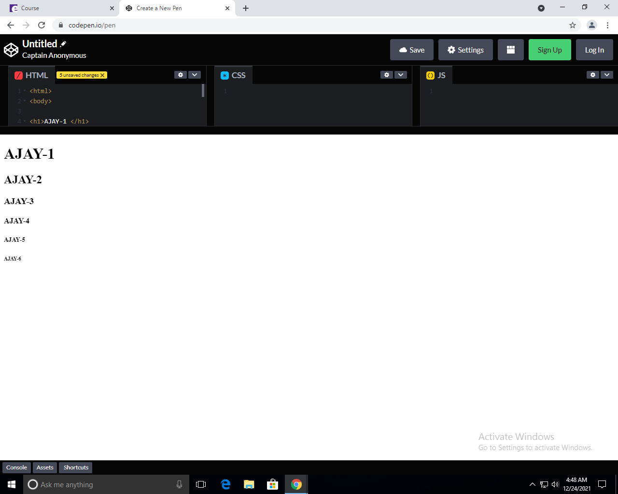

# WEEK – 2

**Aim**: To design the homepage with image tags and paragraph,bold,italic tags.

1. **What is the difference between b/n heading , title , body?**

Heading fonts and body fonts are part of the templates available to you as part of your brand.

Heading fonts are used as larger, higher impact text, such as in a title or section header

Body fonts are usually used with longer text, like a paragraph or secondary text.  We recommend an easy-to-read font that pairs well with your heading font. You may want to choose an easy to read font that compliments your heading font choice. Body fonts also support bold and italics styles.  If you’d like you can select your regular font, and we will build the italics and bold styles automatically for you, but your text will look its best when you also upload the font files all the text styling options.

1. **What is the difference between web app****lication and mobile application**

|  |
| --- |
| A difference between these two types of apps is that web apps require an active Internet connection in order to function, whereas mobile apps can often function while offline |
| Mobile apps tend to be faster and more efficient than web apps, but in order to maintain optimum functionality, users must regularly download updates, whereas web apps update themselves |
| Function in-browser, and therefore do not need to be downloaded or installed whereas mobile application need to install |
| webapps easier and faster to build than mobile apps |
| speed:-mobile application faster and web are slow |
| application is more than web application. |

1. **List out various types of tags?.**

## Various types of Tags:

* **Title tag:**

The <title> tag defines the title of the document. The title must be text-only, and it is shown in the browser's title bar or in the page's tab.

The <title> tag is required in HTML documents!

The contents of a page title is very important for search engine optimization (SEO)! The page title is used by search engine algorithms to decide the order when listing pages in search results.

The <title> element:

* defines a title in the browser toolbar
* provides a title for the page when it is added to favorites
* displays a title for the page in search-engine resume
* **Strong Tag:**

The <strong> tag is used to define text with strong importance. The content inside is typically displayed in **bold**.

* **Center Tag:**

<center> ……………….. </center> : places at the center of web-page

* **Small tags:**
* 1. <b> ………………. </b> : bolds the string
* 2. <U> ………………………….. </U> : underlines the string
* 3. <i> …………………………. </i> : string will be in italic style

**Image tag:**

<img src “pic url” align=”right” or align=”left” or align=”center” width=”100” height=”100” >

Src : image source

Width & height : they are image dimensions

**Hyper – link tag:**

<a href=”link url”> link-name </a>

**Program:**

|  |
| --- |
|  |
|  | <html> |
|  |  |
|  | <body bgcolor="azure"> |
|  |  |
|  | </head> |
|  | <body> |
|  |  |
|  | <center><h1 align="center" style="color:red;"><b><i><u>Resume</u></i></b></h1></center> |
|  |  |
|  | <img src="https://ajaykumarvarma.github.io/Labs/web%20programming/week4-web-resume-3frames/mypic.jpg" alt="AJAY" align=right width="200" height="200"> |
|  | <h2>N.Ajay Kumar Varma</h3> |
|  | <h4>9392593332</h4> |
|  | <h4>ajaynagaraju32@gmail.com</h4> |
|  | <h4 >ajaykumar32</h4> |
|  |  |
|  | <b><i><p>I'm Ajay Kumar Varma studying btech Second year in vrsec in branch of Information Technology.I have completed my intermediate in Narayana college vijayawada and my tenth class in Narayana school.My goal is to become a software engineer and cyber security.My dream company is amazon,and any good cyber security related company.Iam well interested in bug bounty,programming,ethical hacking.My dream package is above 12 lakh.My hobbies are reading books,completing courses and get certificates,learning new things etc.. and Coming to my parents details my father name is ncs raju and mother name is Sireesha.My father occupation is pvt employee and my mother is house wife.My role model is my sister.</p></i></b> |
|  | </body> |
|  | </html> |
|  |  |

**OUTPUT:**

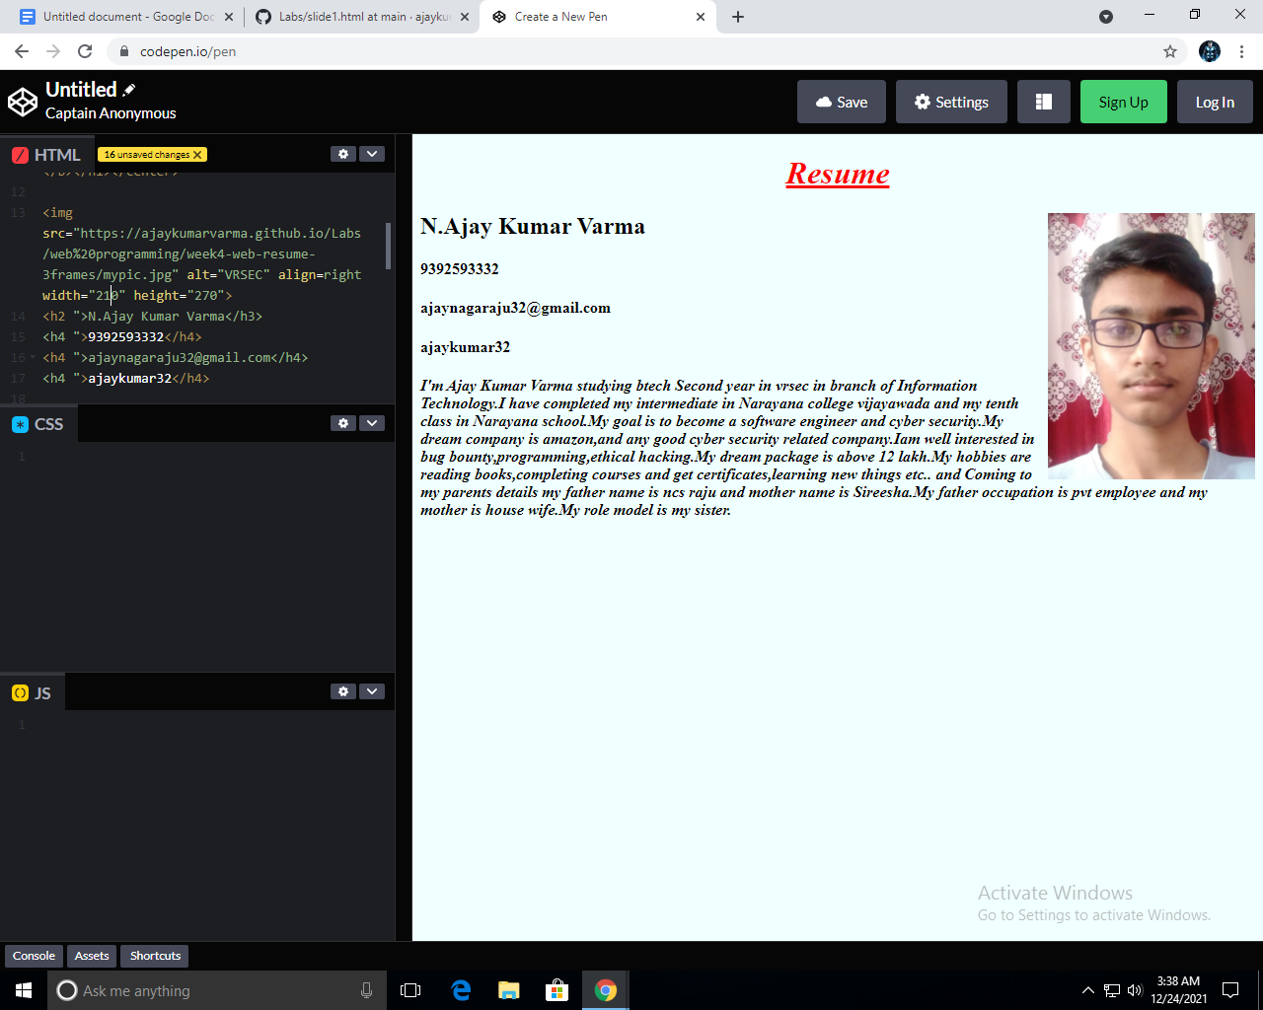

# WEEK-3

**Aim**: Create an Ordered and unordered Lists and Insert an Video,audio Into an webpage

## 

## Lists:

**What are lists in HTML language and types of Lists?**

There are 2 types of lists and they are:

* Ordered Lists
* Unordered Lists

**Ordered Lists:**

* An ordered list starts with the <ol> tag. Each list item starts with the <li> tag.The list items will be marked with numbers by default.
* The HTML <ol> tag defines an ordered list. An ordered list can be numerical or alphabetical.

**Type attributes in Ordered list:**

The type attribute of the <ol> tag, defines the type of the list item marker:

|  |  |
| --- | --- |
| **Type** | **Description** |
| type="1" | The list items will be numbered with numbers (default) |
| type="A" | The list items will be numbered with uppercase letters |
| type="a" | The list items will be numbered with lowercase letters |
| type="I" | The list items will be numbered with uppercase roman numbers |
| type="i" | The list items will be numbered with lowercase roman numbers |

**Syntax: (ordered list)**

<ol type=” ”>

<li>………………………………….</li>

<li> …………………………………..</li>

<li>………………………………….</li>

<ol>

* Use the HTML <ol> element to define an ordered list
* Use the HTML type attribute to define the numbering type
* Use the HTML <li> element to define a list item
* Lists can be nested
* List items can contain other HTML elements

## Unordered List:

## 1)An unordered list starts with the <ul> tag. Each list item starts with the <li> tag.

## 2)The list items will be marked with bullets (small black circles) by default

## 3)The HTML <ul> tag defines an unordered (bulleted) list.

**Type attributes in unordered lists:**

* The type attribute of the <ul> tag, defines the type of the list item marker:

|  |  |
| --- | --- |
| **Value** | **Description** |
| disc | Sets the list item marker to a bullet (default) |
| circle | Sets the list item marker to a circle |
| square | Sets the list item marker to a square |
| none | The list items will not be marked |

**Unordered lists syntax:**

<ul type=””>

<li>……………………………….</li>

<li>………………………………..</li>

<li>…………………………………</li>

<ul>

**Video Tag:**

The <video> tag is used to embed video content in a document, such as a movie clip or other video streams.

The <video> tag contains one or more [<source>](https://www.w3schools.com/tags/tag_source.asp) tags with different video sources. The browser will choose the first source it supports.

The text between the <video> and </video> tags will only be displayed in browsers that do not support the <video> element.

There are three supported video formats in HTML: MP4, WebM, and OGG.

**Attributes in video tag:**

|  |  |  |
| --- | --- | --- |
| **Attribute** | **Value** | **Description** |
| [autoplay](https://www.w3schools.com/tags/att_video_autoplay.asp) | autoplay | Specifies that the video will start playing as soon as it is ready |
| [controls](https://www.w3schools.com/tags/att_video_controls.asp) | controls | Specifies that video controls should be displayed (such as a play/pause button etc). |
| [height](https://www.w3schools.com/tags/att_video_height.asp) | *pixels* | Sets the height of the video player |
| [loop](https://www.w3schools.com/tags/att_video_loop.asp) | loop | Specifies that the video will start over again, every time it is finished |
| [muted](https://www.w3schools.com/tags/att_video_muted.asp) | muted | Specifies that the audio output of the video should be muted |
| [poster](https://www.w3schools.com/tags/att_video_poster.asp) | *URL* | Specifies an image to be shown while the video is downloading, or until the user hits the play button |
| [preload](https://www.w3schools.com/tags/att_video_preload.asp) | auto metadata none | Specifies if and how the author thinks the video should be loaded when the page loads |
| [src](https://www.w3schools.com/tags/att_video_src.asp) | *URL* | Specifies the URL of the video file |
| [width](https://www.w3schools.com/tags/att_video_width.asp) | *pixels* | Sets the width of the video player |

**Syntax for Video tag:**

<video width = “ “ height = “ ” poster = “.png/.jpeg/url“ controls>

<source src = “url or path of file.mp4” type = “video/mp4”>

(or)

<source src = “url or path of file.ogg” type = “video/ogg”>

</video>

**Audio Tag:**

The <audio> tag is used to embed sound content in a document, such as music or other audio streams.

The <audio> tag contains one or more [<source>](https://www.w3schools.com/tags/tag_source.asp) tags with different audio sources. The browser will choose the first source it supports.

The text between the <audio> and </audio> tags will only be displayed in browsers that do not support the <audio> element.

There are three supported audio formats in HTML: MP3, WAV, and OGG.

**Attributes in Audio tag:**

|  |  |  |
| --- | --- | --- |
| **Attribute** | **Value** | **Description** |
| [autoplay](https://www.w3schools.com/tags/att_audio_autoplay.asp) | autoplay | Specifies that the audio will start playing as soon as it is ready |
| [controls](https://www.w3schools.com/tags/att_audio_controls.asp) | controls | Specifies that audio controls should be displayed (such as a play/pause button etc) |
| [loop](https://www.w3schools.com/tags/att_audio_loop.asp) | loop | Specifies that the audio will start over again, every time it is finished |
| [muted](https://www.w3schools.com/tags/att_audio_muted.asp) | muted | Specifies that the audio output should be muted |
| [preload](https://www.w3schools.com/tags/att_audio_preload.asp) | auto metadata none | Specifies if and how the author thinks the audio should be loaded when the page loads |
| [src](https://www.w3schools.com/tags/att_audio_src.asp) | *URL* | Specifies the URL of the audio file |

**Syntax for Audio Tag:**

<audio controls>

<source src = “url or path of file.mp3” type = “audio/mpeg”>

(or)

<source src = “url or path of file.ogg” type = “audio/ogg”>

</audio>

**Program-1:**

|  |
| --- |
|  |

<html>

<body bgcolor="azure">

</head>

<body>

<center><h1 align="center" style="color:red;"><b><i><u>Resume</u></i></b></h1></center>

<img src="https://ajaykumarvarma.github.io/Labs/web%20programming/week4-web-resume-3frames/mypic.jpg" alt="VRSEC" align=right width="200" height="200"">

<h2>N.Ajay Kumar Varma</h3>

<h4>Contact Number: 9392593332</h4>

<h4>Email: ajaynagaraju32@gmail.com</h4>

<p> <a href="https://github.com/ajaykumarvarma">Github Profile</a></p>

<p>I'm Ajay Kumar Varma. My age is 18. I'm studying btech Second year in vrsec in branch of Information Technology.I have completed my intermediate in Narayana college vijayawada and my tenth class in Narayana school.My goal is to become a software engineer and cyber security.My dream company is amazon,and any good cyber security related company.Iam well interested in bug bounty,programming,ethical hacking.My dream package is above 12 lakh.My hobbies are reading books,completing courses and get certificates,learning new things etc.. and Coming to my parents details my father name is ncs raju and mother name is Sireesha.My father occupation is pvt employee and my mother is house wife.My role model is my sister.</p>

<h2>My Skill Set</h2>

<h3>Languages Known:</h3>

<ol type="1">

<li>English</li>

<li>Telugu</li>

<li>Hindi</li>

</ol>

<h3>Programming Languages Known:</h3>

<ol type="1">

<li>Python</li>

<li>c</li>

<li>c++</li>

<p> <b> Self-Affirmation Video </b> </p>

<video width = "350" height = "250" controls>

<source src = "https://ajaykumarvarma.github.io/Labs/web%20programming/VIDEO%20RESUME.mp4">

</video>

<p> <b>Self-Affirmation Audio </b> </p>

<audio controls>

<source src = "https://ajaykumarvarma.github.io/Labs/web%20programming/AUDIORESUME.mp3">

</audio>

<p> <b> Hobbies: </b> </p>

<ul type="disc">

<li> Listening Music </li>

<li> Browsing in internet </li>

<li> Improving coding skills </li>

</ul>

<br>

<h2>Other Details:</h2>

<p> DOB: 30-05-2003 </p>

<p> Age: 18 </p>

<p> Fathers name: Ncs Raju </p>

<p> Address: 74-10-1/9,Road No:9,Electricity Colony,Patamata,Vijayawada </p>

</ul>

</body>

</html>

**Program-2:**

|  |
| --- |
|  |

|  |
| --- |
| <html> |
|  | <body> |
|  | <title>Lists</title> |
|  | <h1 align="center"><b><u>Different types of lists</u></b></h1> |
|  | <h2><u>Ordered list:</u></h2> |
|  | <h3>Friends:</h3> |
|  | <ol type="1"> |
|  | <li>Rizwan</li> |
|  | <li>Sai</li> |
|  | <li>charan</li> |
|  | <li>Mounav</li> |
|  |  |
|  | </ol> |
|  | <h3>Cars:</h3> |
|  | <ol type="a"> |
|  | <li>Audi</li> |
|  | <li>Benz</li> |
|  | <li>Rolls Roice</li> |
|  | <li>Ferrari</li> |
|  |  |
|  | </ol> |
|  | <h3>Bikes:</h3> |
|  | <ol type="A"> |
|  | <li>Ducati</li> |
|  | <li>Pulsar</li> |
|  | <li>R15</li> |
|  | <li>Gixer</li> |
|  |  |
|  | </ol> |
|  | <h3>Flowers:</h3> |
|  | <ol type="I"> |
|  | <li>Rose</li> |
|  | <li>Lilly</li> |
|  | <li>SunFlower</li> |
|  | <li>Tulips</li> |
|  |  |
|  | </ol> |
|  |  |
|  | <h2><u>Un ordered list:</u></h2> |
|  | <h3>Programing Languages:</h3> |
|  | <ul> |
|  | <li>Python</li> |
|  | <li>cpp</li> |
|  | <li>c</li> |
|  | <li>java</li> |
|  | </ul> |
|  | <h3>Social Media:</h3> |
|  | <ul style="list-style-type:square;"> |
|  | <li>Facebook</li> |
|  | <li>Whatsapp</li> |
|  | <li>Instagram</li> |
|  | <li>Twitter</li> |
|  | </ul> |
|  | <h3>Cool Drinks:</h3> |
|  | <ul style="list-style-type:circle;"> |
|  | <li>Thumbsup</li> |
|  | <li>Sprite</li> |
|  | <li>Maaza</li> |
|  | <li>7up</li> |
|  | </ul> |
|  | <h3>Mnc's:</h3> |
|  | <ul style="list-style-type:none;"> |
|  | <li>Amazon</li> |
|  | <li>Microsoft</li> |
|  | <li>Google</li> |
|  | <li>Airbus</li> |
|  | </ul> |
|  |  |
|  |  |
|  | </body> |
|  | </html> |

**OUTPUT:**

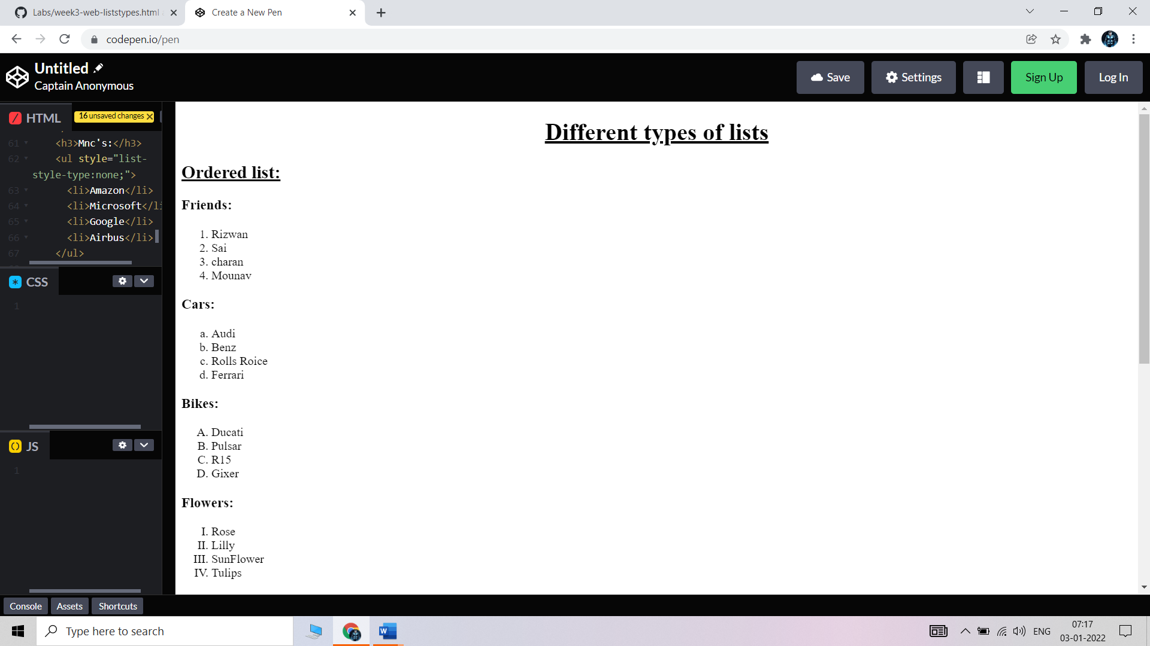

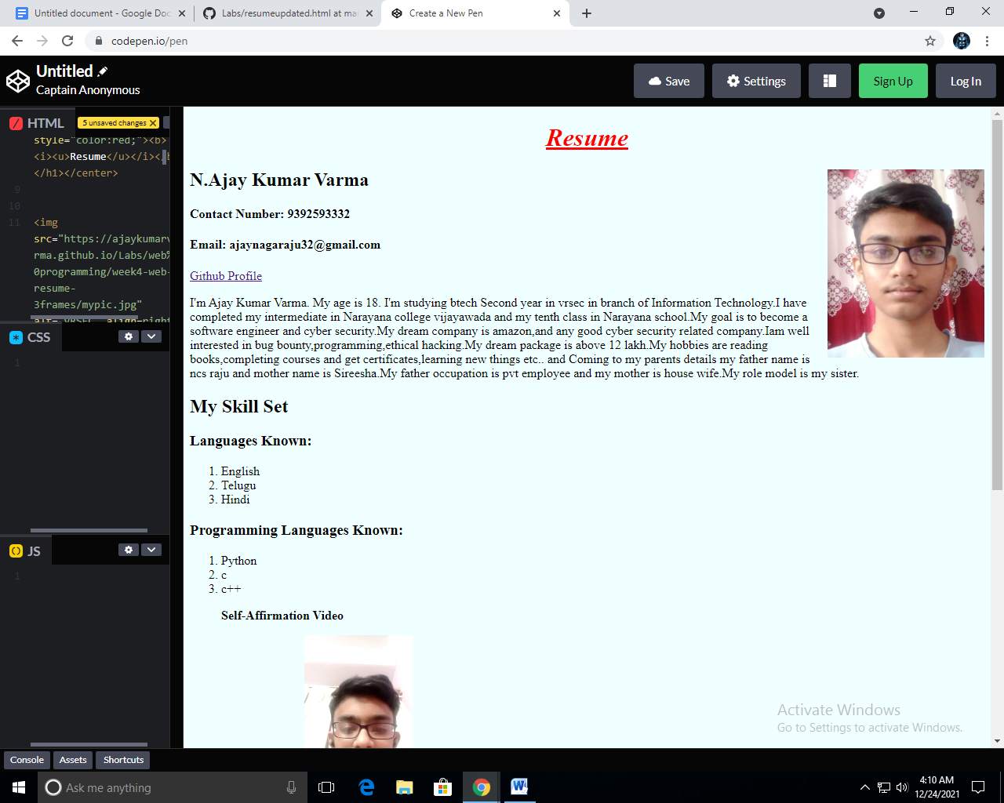

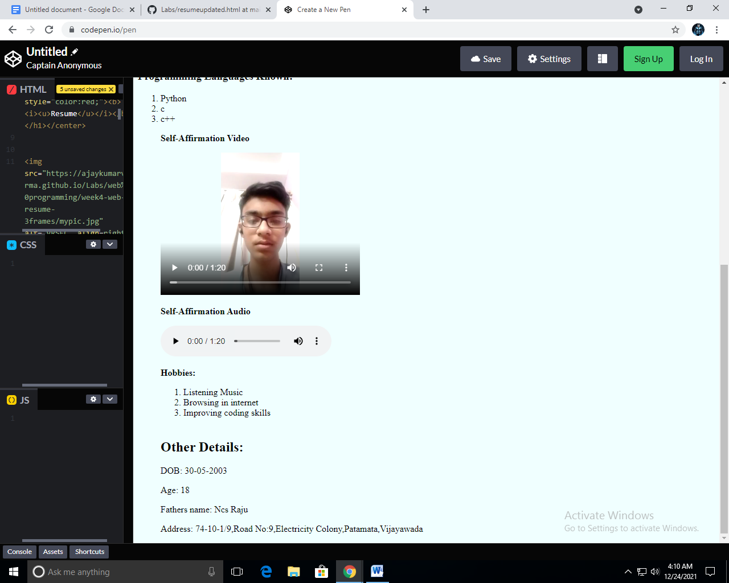

**OUTPUT UNORDERED LIST:-**

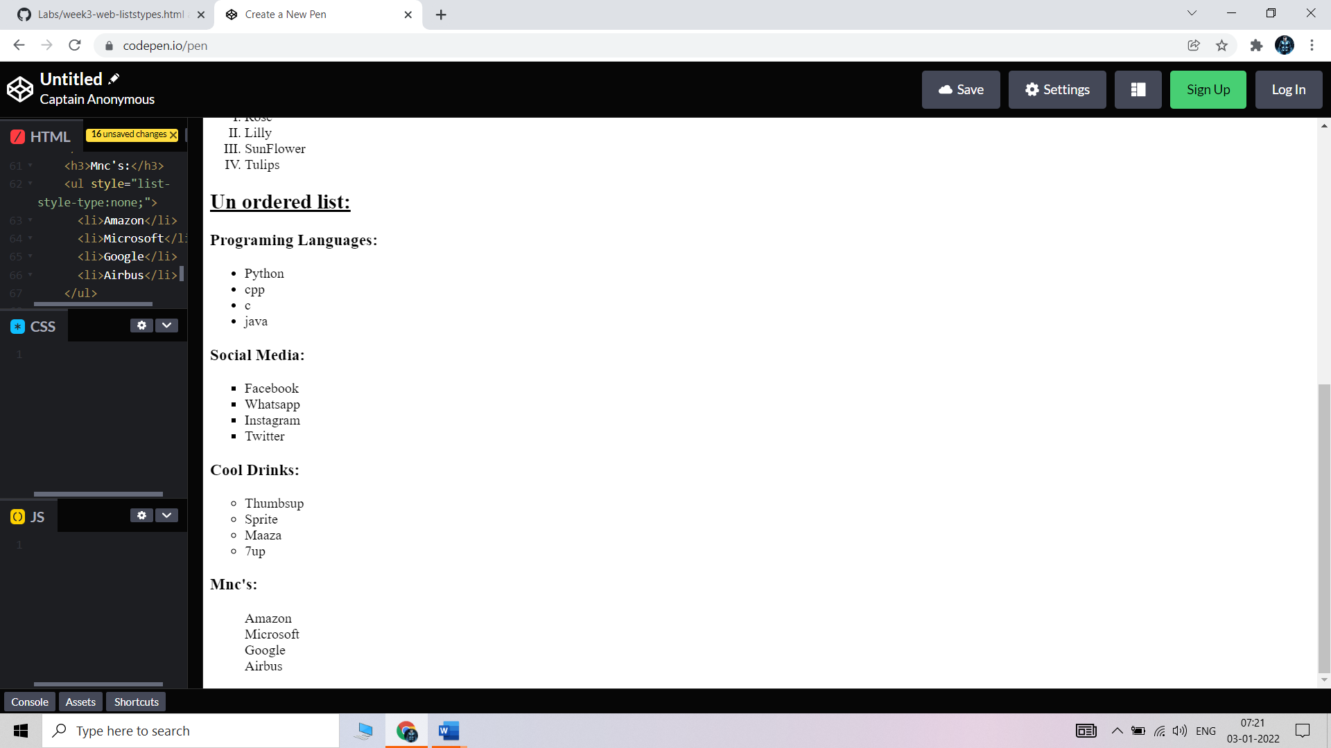

# Week – 4

**Aim**: Create an your Resume by using framset tag and using HTML language.

## **Frameset:**

The <frameset> tag in HTML is used to define the frameset. The

<frameset> element contains one or more frame elements. It is used to specify the number of rows and columns in frameset with their pixel of spaces. Each element can hold a separate document.

HTML frames are used to divide your browser window into multiple sections where each section can load a separate HTML document. A collection of frames in the browser window is known as a frameset. The window is divided into frames in a similar way the tables are organized: into rows and columns.

## 

## **Attributes in Frameset:**

**cols**: The cols attribute is used to create vertical frames in a web browser. This attribute is basically used to define the no. of columns and their size inside the frameset tag.

**rows:** The rows attribute is used to create horizontal frames in the web browser. This attribute is used to define the no. of rows and their size inside the frameset tag.

**border:** This attribute of frameset tag defines the width of the border of each frame in pixels. Zero value is used for no border.

**frameborder:** This attribute of frameset tag is used to specify whether a three-dimensional border should be displayed between the frames or not for this use two values 0 and 1, where 0 defines no border and value 1 signifies for yes there will be a border.

**framespacing:** This attribute of frameset tag is used to specify the amount of spacing between the frames in a frameset. This can take any integer value as a parameter which basically denotes the value in pixel.

**Syantax For Column’s Division:**

<frameset cols = “n1%, n2%, n3%>

<frame name = “top” src = “first file.html” />

<frame name = “main” src = “second file.html” />

<frame name = “bottom” src = “third file.html” />

.

.

.

.

<noframes>

<body>

You can write here documentation.

n1,n2,n3 are the division of web-page percentages.

</body>

</noframes>

</frameset>

**Syantax For Row’s Division:**

<frameset rows = “n1%, n2%, n3%>

<frame name = “top” src = “first file.html” />

<frame name = “main” src = “second file.html” />

<frame name = “bottom” src = “third file.html” />

.

.

.

.

<noframes>

<body>

You can write here documentation.

n1,n2,n3 are the division of web-page percentages.

</body>

</noframes>

</frameset>

**Program:**

|  |  |
| --- | --- |
|  | |
| <html> | |
|  | | <head> |
|  | | <title>Resume</title> |
|  | | </head> |
|  | |  |
|  | | <frameset cols = "25%, 38%, 37%"> |
|  | | <frame name = "top" src = "[slide1.html](https://webprogramming.ajaykumarvarma.live/web%20programming/week4-web-resume-3frames/slide1.html)" /> |
|  | | <frame name = "main" src = "[slide2.html](https://webprogramming.ajaykumarvarma.live/web%20programming/week4-web-resume-3frames/slide2.html)" /> |
|  | | <frame name = "bottom" src = "[slide3.html](https://webprogramming.ajaykumarvarma.live/web%20programming/week4-web-resume-3frames/slide3.html)" /> |
|  | | <noframes> |
|  | | <body>The browser you are working does |
|  | | not support frames.</body> |
|  | | </noframes> |
|  | | </frameset> |
|  | | </html> |

**OUTPUT:**

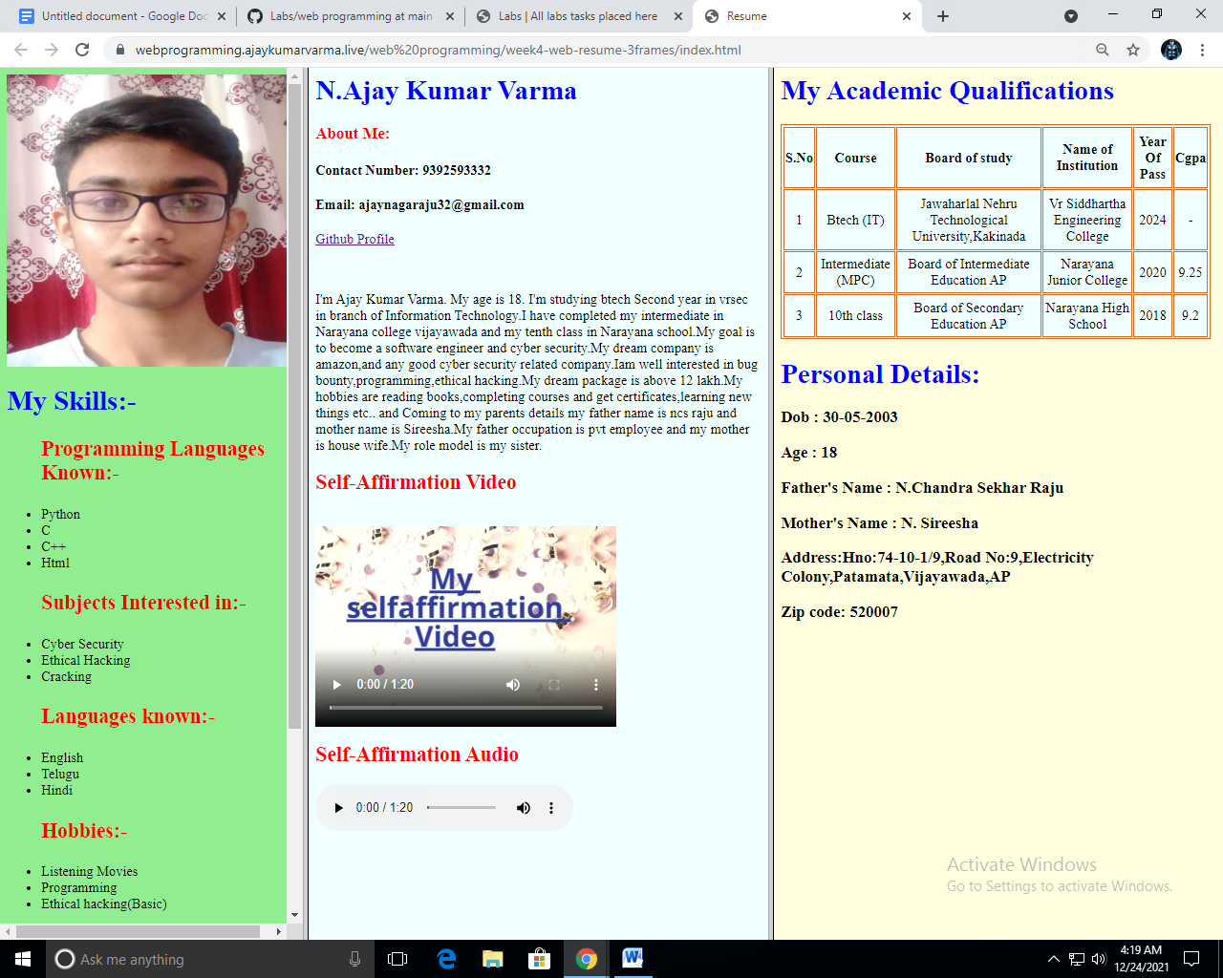

# WEEK – 5

**Aim**: To create an Academic Qualifications Table using Table tag in HTML

## 

## **Tables:**

* HTML tables allow web developers to arrange data into rows and columns.
* The HTML tables are created using the **<table>** tag in which the **<tr>** tag is used to create table rows and **<td>** tag is used to create data cells. The elements under <td> are regular and left aligned by default

**Table Heading:**

* Table heading can be defined using **<th>** tag. This tag will be put to replace <td> tag, which is used to represent actual data cell. Normally you will put your top row as table heading as shown below, otherwise you can use <th> element in any row. Headings, which are defined in <th> tag are centered and bold by default.

**Cellpadding and Cellspacing:**

* There are two attributes called cellpadding and cellspacing which you will use to adjust the white space in your table cells. The cellspacing attribute defines space between table cells, while cellpadding represents the distance between cell borders and the content within a cell.

**Table Height and Width:**

* You can set a table width and height using width and height attributes. You can specify table width or height in terms of pixels or in terms of percentage of available screen area.

**Table Backgrounds:**

1)You can set table background using one of the following two ways −

2)bgcolor attribute − You can set background color for whole table or just for one cell.

3)background attribute − You can set background image for whole table or just for one cell.

4)You can also set border color also using bordercolor attribute

Table Header: use <th> ……………………………… </th>

Table rows or colums: use <tr> ………………………… </tr>

Table Data: use <tc> …………………………………….. </tc>

## Attributes in Table Tag:

|  |  |
| --- | --- |
| **Tag** | **Description** |
| [<table>](https://www.w3schools.com/tags/tag_table.asp) | Defines a table |
| [<th>](https://www.w3schools.com/tags/tag_th.asp) | Defines a header cell in a table |
| [<tr>](https://www.w3schools.com/tags/tag_tr.asp) | Defines a row in a table |
| [<td>](https://www.w3schools.com/tags/tag_td.asp) | Defines a cell in a table |
| [<caption>](https://www.w3schools.com/tags/tag_caption.asp) | Defines a table caption |
| [<colgroup>](https://www.w3schools.com/tags/tag_colgroup.asp) | Specifies a group of one or more columns in a table for formatting |
| [<col>](https://www.w3schools.com/tags/tag_col.asp) | Specifies column properties for each column within a <colgroup> element |
| [<thead>](https://www.w3schools.com/tags/tag_thead.asp) | Groups the header content in a table |
| [<tbody>](https://www.w3schools.com/tags/tag_tbody.asp) | Groups the body content in a table |
| [<tfoot>](https://www.w3schools.com/tags/tag_tfoot.asp) | Groups the footer content in a table |

**Syntax For Table:**

<table border = “ ” width = “ ” height = “ ” cellspacing = “ ” bordercolor = “ ” bgcolor = “ ” >

<tr>

<th> ……………………………………….. </th>

.

.

.

</tr>

<tr>

<td> ………………………………………… </td>

<td> ……………………………………….. </td>

.

.

.

.

</tr>

.

.

</table>

**Program:**

|  |
| --- |
|  |

<html>

<body>

<table border="2" width="670" height="275" bordercolor="chocolate" bgcolor="azure" >

<tr>

<th>S.No</th>

<th>Course</th>

<th>Board of study</th>

<th>Name of Institution</th>

<th>Year Of Pass</th>

<th>Cgpa</th>

</tr>

<tr>

<td align="center">1</td>

<td align="center">Btech (IT)</td>

<td align="center">Jawaharlal Nehru Technological University,Kakinada</td>

<td align="center">Vr Siddhartha Engineering College</td>

<td align="center">2024</td>

<td align="center">-</td>

</tr>

<tr>

<td align="center">2</td>

<td align="center">Intermediate (MPC)</td>

<td align="center">Board of Intermediate Education AP</td>

<td align="center">Narayana Junior College</td>

<td align="center">2020</td>

<td align="center">9.25</td>

</tr>

<tr>

<td align="center">3</td>

<td align="center">10th class</td>

<td align="center">Board of Secondary Education AP</td>

<td align="center">Narayana High School</td>

<td align="center">2018</td>

<td align="center">9.2</td>

</tr>

</table>

</body>

</html>

**OUTPUT:**

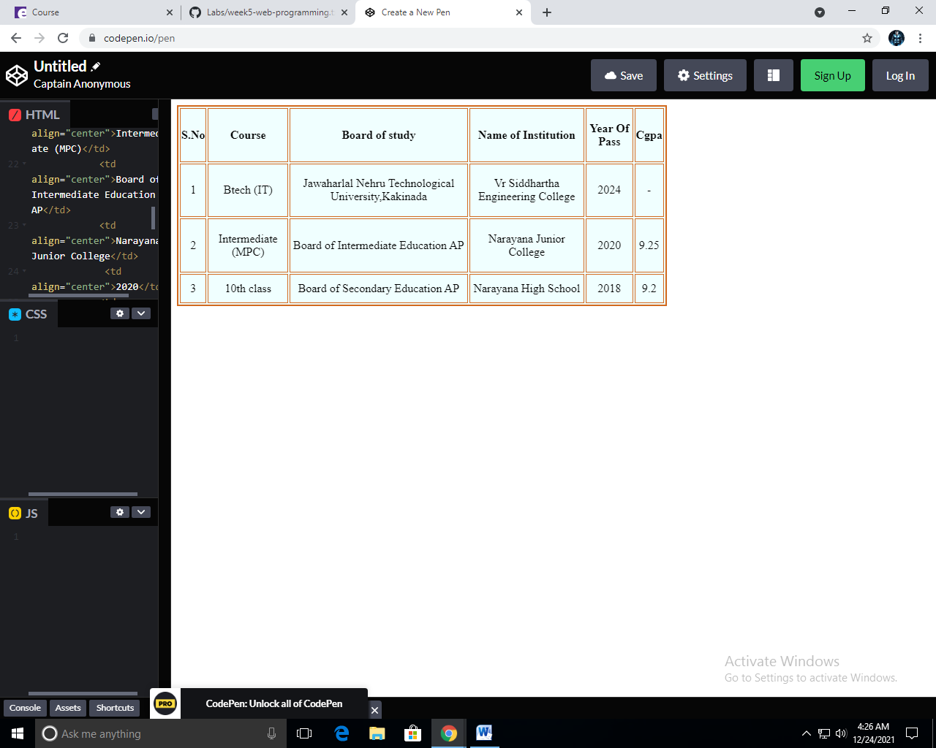

**Week - 7**

1. **Aim** : Create a Form using HTML

**Code :**

<html>

<body bgcolor="lightblue">

<h2 align="center" > Fill the Below Form for Resume </h2>

<form>

First Name : <input type = "text" name = "fn" / >

Last Name : <input type = "text" name = "ln" />

<br>

Father's Name :<br> <input type = "text" name = "fn"/>

<br>

Mother's Name :<br> <input type = "text" name = "mn" />

<br>

Date of Birth : <br>

Date : <input type = "text" name = "password" />

Month : <input type = "text" name = "password" />

Year : <input type = "text" name = "password" />

<br>

Email :<br> <input type = "text" name = "text" />

<br>

Phone Number :<br> <input type = "text" name = "password" />

<br>

Address :<br> <input type = "text" name = "password" />

<p> Gender : </p>

<input type = "radio" name = "subject" value = "Male"> Male

<input type = "radio" name = "subject" value = "Female"> Female

<input type = "radio" name = "subject" value = "Others"> Others

<p> Intrests : </p>

<input type = "checkbox" name = "Software development" value = "on"> Software development <br>

<input type = "checkbox" name = "Data analysis" value = "on"> Data analysis <br>

<input type = "checkbox" name = "Network security" value = "on"> Network security <br>

<input type = "checkbox" name = "Computer hardware" value = "on">Computer hardware <br>

<p> Programming Languages : </p>

<input type = "checkbox" name = "C" value = "on"> C <br>

<input type = "checkbox" name = "C++" value = "on"> C++<br>

<input type = "checkbox" name = "Python" value = "on"> Python<br>

<input type = "checkbox" name = "Java"value = "on"> Java <br>

<p> Hobbies : </p>

1.<input type = "text" name = "text" /> <br>

2.<input type = "text" name = "text"/> <br>

3.<input type = "text" name = "text" /> <br>

4.<input type = "text" name = "text" /> <br>

<p> Achievement :</p>

1.<input type = "text" name = "text" /> <br>

2.<input type = "text" name = "text"/> <br>

3.<input type = "text" name = "text" /> <br>

4.<input type = "text" name = "text" /> <br>

</form>

<br>

<input type="submit" value="Submit">

<input type="Reset" value="Reset">

</body>

</html>

**OUTPUT:**

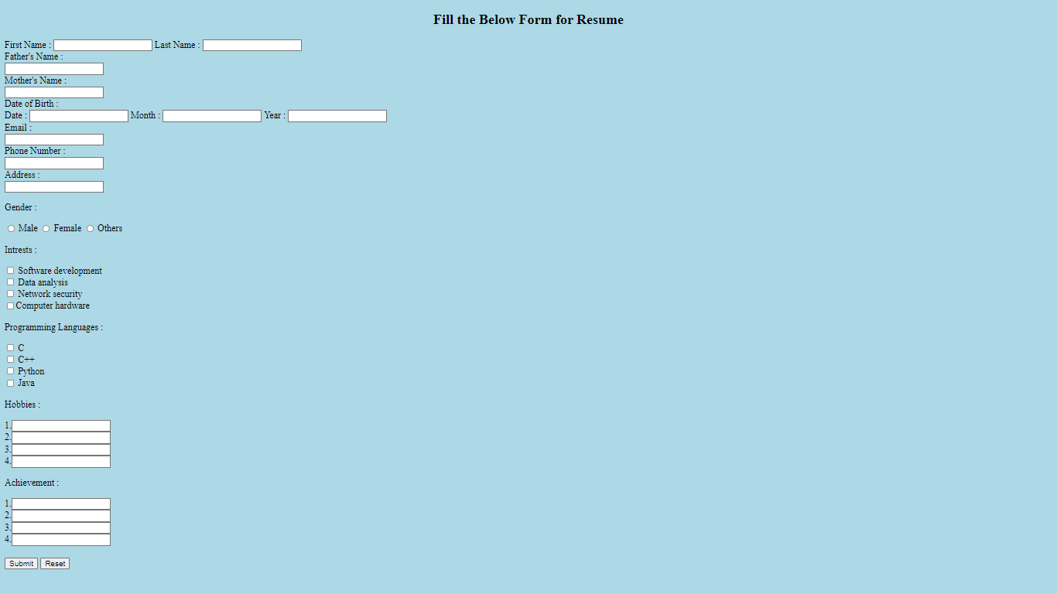

**Week - 8**

**1.Aim :** Create a website using HTML.

CODE:

|  |
| --- |
| <html lang="en"> |
|  |  |
|  | <head> |
|  | <meta charset="UTF-8"> |
|  | <meta http-equiv="X-UA-Compatible" content="IE=edge"> |
|  | <meta name="viewport" content="width=device-width, initial-scale=1.0"> |
|  | <link rel="apple-touch-icon" sizes="180x180" |
|  | href="<https://media.istockphoto.com/vectors/ransomware-icon-vector-on-white-background-ransomware-trendy-filled-vector-id1095638720>" /> |
|  | <link rel="icon" type="image/png" sizes="32x32" |
|  | href="<https://media.istockphoto.com/vectors/ransomware-icon-vector-on-white-background-ransomware-trendy-filled-vector-id1095638720>" /> |
|  | <link rel="icon" type="image/png" sizes="16x16" |
|  | href="<https://media.istockphoto.com/vectors/ransomware-icon-vector-on-white-background-ransomware-trendy-filled-vector-id1095638720>" /> |
|  | <style> |
|  | @import url('https://fonts.googleapis.com/css2?family=Poppins:wght@100;200;300;400;500;600;700;800;900&display=swap'); |
|  |  |
|  | @import url('https://fonts.googleapis.com/css2?family=Supermercado+One&display=swap'); |
|  |  |
|  | * { |
|  | margin: 0; |
|  | padding: 0; |
|  | box-sizing: border-box; |
|  | font-family: 'Poppins', sans-serif; |
|  | } |
|  |  |
|  |  |
|  | .heading { |
|  | text-align: center; |
|  | margin: 25px 0; |
|  | font-family: 'Supermercado One', cursive; |
|  | font-size: 43px; |
|  | } |
|  |  |
|  | .headingsecond { |
|  | text-align: center; |
|  | margin: 20px 0; |
|  | font-family: 'Supermercado One', cursive; |
|  | font-size: 25px; |
|  | } |
|  |  |
|  | nav { |
|  | display: flex; |
|  | padding: 50% 50% justify-content: space-between; |
|  | align-items: center; |
|  |  |
|  | background-color: #FFC300; |
|  | font-family: "Montserrat", sans-serif; |
|  | } |
|  |  |
|  | .nav-links { |
|  | flex: 1; |
|  | text-align: right; |
|  |  |
|  | } |
|  |  |
|  | .nav-links ul li { |
|  | list-style: none; |
|  | display: inline-block; |
|  | padding: 9px 12px; |
|  | position: relative; |
|  | font-size: 20px; |
|  | font-weight: 200; |
|  | } |
|  |  |
|  | .nav-links ul li a { |
|  | color: #fff; |
|  | text-decoration: none; |
|  | font-size: 20px; |
|  | ; |
|  | } |
|  |  |
|  | .nav-links ul li::after { |
|  | content: ''; |
|  | width: 0%; |
|  | height: 2px; |
|  | display: block; |
|  | background: #f44336; |
|  | margin: auto; |
|  |  |
|  | } |
|  |  |
|  | .nav-links ul li:hover::after { |
|  | width: 100%; |
|  | } |
|  |  |
|  |  |
|  | .headingthird { |
|  | color: white; |
|  | text-transform: uppercase; |
|  | letter-spacing: 5px; |
|  | font-size: 25px; |
|  | margin-left: 20px; |
|  | } |
|  |  |
|  |  |
|  | .content { |
|  | font-size: 20px; |
|  | padding: 20px; |
|  | background: #40E0D0; |
|  | background: -webkit-linear-gradient(to right, #FF0080, #FF8C00, #40E0D0); |
|  | background: linear-gradient(to right, #FF0080, #FF8C00, #40E0D0); |
|  | -webkit-text-fill-color: transparent; |
|  | -webkit-background-clip: text; |
|  | font-weight: 500; |
|  | } |
|  |  |
|  | .box { |
|  | display: grid; |
|  | grid-template-columns: 1fr 1fr; |
|  | column-gap: 20px; |
|  | justify-content: center; |
|  | align-items: center; |
|  | margin: 20px 40px; |
|  | } |
|  |  |
|  | .hero-img { |
|  | display: block; |
|  | margin-left: auto; |
|  | margin-right: auto; |
|  | width: 380px; |
|  | border-radius: 10px; |
|  | } |
|  |  |
|  | button { |
|  | display: inline-block; |
|  | background-color: #D8C09A; |
|  | border-radius: 10px; |
|  | border: 4px double #cccccc; |
|  | color: #eeeeee; |
|  | text-align: center; |
|  | font-size: 21px; |
|  | padding: 7px; |
|  | width: 235px; |
|  | -webkit-transition: all 0.5s; |
|  | -moz-transition: all 0.5s; |
|  | -o-transition: all 0.5s; |
|  | transition: all 0.5s; |
|  | cursor: pointer; |
|  | margin: 8px; |
|  | } |
|  |  |
|  | button a { |
|  | text-decoration: none; |
|  | color: black; |
|  | } |
|  |  |
|  | button { |
|  | border-radius: 10px; |
|  | } |
|  |  |
|  | button:hover { |
|  | background-color: green; |
|  | } |
|  |  |
|  |  |
|  | .footer { |
|  | background: #1193DA; |
|  | color: white; |
|  | padding: 1rem; |
|  | } |
|  |  |
|  | .grid-wrap { |
|  | display: grid; |
|  | grid-template-columns: repeat(4, 1fr); |
|  | margin: 10px 10%; |
|  | } |
|  | .flex { |
|  | display: flex; |
|  | flex-direction: column; |
|  | } |
|  | .heading-foot { |
|  | font-weight: bold; |
|  | text-transform: uppercase; |
|  | margin: 20px 0; |
|  | font-size: 1.2rem; |
|  | } |
|  | .col a { |
|  | text-decoration: none; |
|  | color: white; |
|  | text-transform: capitalize; |
|  | padding: 5px 0; |
|  | } |
|  | .end-line { |
|  | display: flex; |
|  | justify-content: space-around; |
|  | background: black; |
|  | color: white; |
|  | padding: 2rem; |
|  | } |
|  |  |
|  | .logo { |
|  | text-transform: uppercase; |
|  | /* font-weight: bold; */ |
|  | font-size: 1.8rem; |
|  | } |
|  | .copy { |
|  | text-transform: capitalize; |
|  | text-align: center; |
|  | } |
|  |  |
|  | .social i { |
|  | font-size: 1.5rem; |
|  | padding: 0 20px; |
|  | color: white; |
|  | } |
|  |  |
|  | .centering { |
|  | display: flex; |
|  | justify-content: center; |
|  | align-items: center; |
|  | } |
|  |  |
|  | .fa-facebook-f:hover { |
|  | color: #3a559f; |
|  | } |
|  |  |
|  | .fa-instagram:hover { |
|  | color: red; |
|  | } |
|  |  |
|  | .fa-linkedin:hover { |
|  | color: #0274b3; |
|  | } |
|  |  |
|  | .fa-twitter:hover { |
|  | color: #01a2ed; |
|  | } |
|  |  |
|  | ul.nysr { |
|  | width: 100%; |
|  | flex-direction: row; |
|  | display: flex; |
|  | flex-wrap: nowrap; |
|  | align-items: stretch; |
|  | list-style: none; |
|  | padding-inline-start: 0; |
|  | } |
|  |  |
|  | li.single-nysr { |
|  | width: 25%; |
|  | margin-left: 10px; |
|  | margin-right: 10px; |
|  | background-color: #f5f5f5; |
|  | text-align: left; |
|  | border: 1px solid #c9c9c9; |
|  | border-radius: .25rem; |
|  | } |
|  |  |
|  | li.single-nysr:first-child { |
|  | margin-left: 0; |
|  | } |
|  |  |
|  | li.single-nysr:last-child { |
|  | margin-right: 0; |
|  | } |
|  |  |
|  | footer p { |
|  | margin: 4rem auto 1rem auto; |
|  | font-size: 1.1rem; |
|  | } |
|  |  |
|  | video.center { |
|  | display: block; |
|  | margin-left: auto; |
|  | margin-right: auto; |
|  | } |
|  |  |
|  | header { |
|  | display: flex; |
|  | justify-content: space-around; |
|  | align-items: center; |
|  | padding: 17px; |
|  | } |
|  |  |
|  |  |
|  | .nav-links li a { |
|  | text-decoration: none; |
|  | padding: 0 30px; |
|  |  |
|  | } |
|  |  |
|  | .nav-links li { |
|  | list-style-type: none; |
|  |  |
|  | } |
|  |  |
|  | .nav-links { |
|  | margin-left: 65%; |
|  | display: flex; |
|  | justify-content: space-between; |
|  |  |
|  | } |
|  |  |
|  | </style> |
|  | <title>Ransomware</title> |
|  | </head> |
|  |  |
|  | <body bgcolor="azure"> |
|  | <nav> |
|  | <header> |
|  | <div class='headingthird'> |
|  | <h3>Ajay Cybersecurity Guides</h3> |
|  | </div> |
|  | <div> |
|  | <ul class='nav-links'> |
|  | <li><a href="[#home](https://cyberthreats.ajaykumarvarma.live/ransomware.html#home)">Home</a></li> |
|  | <li><a href="[#news](https://cyberthreats.ajaykumarvarma.live/ransomware.html#news)">News</a></li> |
|  | <li><a href="<https://t.me/ajayownerofhg>">Contact</a></li> |
|  | <li><a href="[#about](https://cyberthreats.ajaykumarvarma.live/ransomware.html#about)">About</a></li> |
|  | </ul> |
|  | </div> |
|  | </nav> |
|  | </header> |
|  | <h1 class="heading">Ransomware</h1> |
|  |  |
|  | <div class="box"> |
|  | <p class="content"> |
|  | Ransomware is a type of malicious software, or malware,that prevents you from accessingyour computer files, |
|  | systems, or networks and demands you pay a ransom for their return. Ransomware attacks can |
|  | cause costly disruptions to operations and the loss of critical information and data. |
|  | </p> |
|  |  |
|  | <img class="hero-img" |
|  | src="<https://media.gettyimages.com/illustrations/lock-abstract-glitch-background-illustration-id1291279260?s=612x612>" /> |
|  |  |
|  | <br> |
|  | </div> |
|  | <h1 class="heading">Some Ransomware Attacks</h1> |
|  | <div class="box"> |
|  |  |
|  | <p class="content">WannaCry: A powerful Microsoft exploit was leveraged to create a worldwide ransomware worm |
|  | that infected over 250,000 systems before a killswitch was tripped to stop its spread. Proofpoint was |
|  | involved in finding the sample used to find the killswitch and in deconstructing the ransomware |
|  | </p> |
|  |  |
|  | <img class="hero-img" |
|  | src="<https://images.theconversation.com/files/169334/original/file-20170515-6987-lw7ou2.png?ixlib=rb-1.1.0&q=45&auto=format&w=926&fit=clip>" /> |
|  |  |
|  |  |
|  |  |
|  | </div> |
|  | <br> |
|  | <div class="box"> |
|  | <p class="content"> |
|  | Bad Rabbit:Bad Rabbit presents nothing new in its subtle techniques: it follows the footsteps of WannaCry |
|  | and NotPetya. It has hit organizations mainly in Russia and Eastern Europe disguised as an Adobe Flash |
|  | installation. It spreads via drive-by downloads on compromised websites where it was inserted into HTML code |
|  | or Java files using JavaScript. Once downloaded and installed, the PC is locked. The ransom is $ 280 in |
|  | bitcoin with a 40-hour-deadline. |
|  | </p> |
|  |  |
|  | <img class="hero-img" |
|  | src="<https://encrypted-tbn0.gstatic.com/images?q=tbn:ANd9GcRWKy00ZA3koG6d_8fFXm4P4juw7DVN8hqZvB4llW1uzPiQiQ0UXQWBKKsESpNHMRbGRns&usqp=CAU>" /> |
|  |  |
|  |  |
|  | </div> |
|  | <br> |
|  | <h1 class="heading">How To Prevent Your Computer/Laptop From Ransomwares!</h1><br> |
|  | <h3 class="headingsecond">Watch Video Below !</h3> |
|  | <center> |
|  | <video width="600" height="450" poster="https://i.ytimg.com/vi/SgYYJnE36RA/maxresdefault.jpg " controls> |
|  | <source |
|  | src="<https://cyberthreats.ajaykumarvarma.live/Ransomware%20and%20How%20to%20Prevent%20a%20Ransomware%20Attack%20(2021).mp4>"> |
|  | </video> |
|  | </center> |
|  | <br><br><br> |
|  | <button class="vertical-center" type="button" |
|  | style="background-color:lightblue;margin-right:auto;margin-left:auto;display:block;margin-top:0%;margin-bottom:3%;border:none;padding:10px 12px;"> |
|  | <a href="<https://www.kaspersky.com/resource-center/threats/ransomware>" target="_blank">View More About |
|  | Ransomware!</a> |
|  | </button> |
|  | <br><br> |
|  | <div class="footer"> |
|  | <div class="grid-wrap"> |
|  | <div class="col flex"> |
|  | <p class="heading-foot">Antivirus Softwares</p> |
|  | <a href="<https://www.bitdefender.com/>">Bitdefender</a> |
|  | <a href="<https://www.malwarebytes.com/>">Malwarebytes</a> |
|  | <a href="<https://www.kaspersky.co.in/>">Kaspersky</a> |
|  | <a href="<https://www.mcafee.com/en-in/index.html>">Mcafee</a> |
|  | </div> |
|  | <div class="col flex"> |
|  | <p class="heading-foot">explore</p> |
|  | <a href="[#](https://cyberthreats.ajaykumarvarma.live/ransomware.html)">community</a> |
|  | <a href="[#](https://cyberthreats.ajaykumarvarma.live/ransomware.html)">blog</a> |
|  | <a href="[#](https://cyberthreats.ajaykumarvarma.live/ransomware.html)">Older Version</a> |
|  | </div> |
|  | <div class="col flex"> |
|  | <p class="heading-foot">AJAY</p> |
|  | <a href="<https://webprogramming.ajaykumarvarma.live/web%20programming/week4-web-resume-3frames/index.html>">about me</a> |
|  | <a href="[#](https://cyberthreats.ajaykumarvarma.live/ransomware.html)">faq</a> |
|  | <a href="[#](https://cyberthreats.ajaykumarvarma.live/ransomware.html)">contact us</a> |
|  | </div> |
|  | <div class="col flex"> |
|  | <p class="heading-foot">legal</p> |
|  | <a href="[#](https://cyberthreats.ajaykumarvarma.live/ransomware.html)">privacy policy</a> |
|  | <a href="[#](https://cyberthreats.ajaykumarvarma.live/ransomware.html)">terms & conditions</a> |
|  | </div> |
|  | </div> |
|  | </div> |
|  | <div class="end-line"> |
|  | <p class="logo">AJAY</p> |
|  | <p class="copy centering">&copy; AJAY CYBERSECURITY GUIDES 2022. All rights reserved</p> |
|  | <div class="social centering"> |
|  | <a href="[#](https://cyberthreats.ajaykumarvarma.live/ransomware.html)"><i class="fab fa-facebook-f"></i></a> |
|  | <a href="<https://www.instagram.com/ajaykumarvarma_32/>"><i class="fab fa-instagram"></i></a> |
|  | <a href="<https://www.linkedin.com/in/nagaraju-ajay-kumar-varma-4b0449228/>"><i class="fab fa-linkedin"></i></a> |
|  | <a href="[#](https://cyberthreats.ajaykumarvarma.live/ransomware.html)"><i class="fab fa-twitter"></i></a> |
|  | </div> |
|  | </div> |
|  | <br> |
|  | </body> |
|  |  |
|  | </html> |

Output ss:

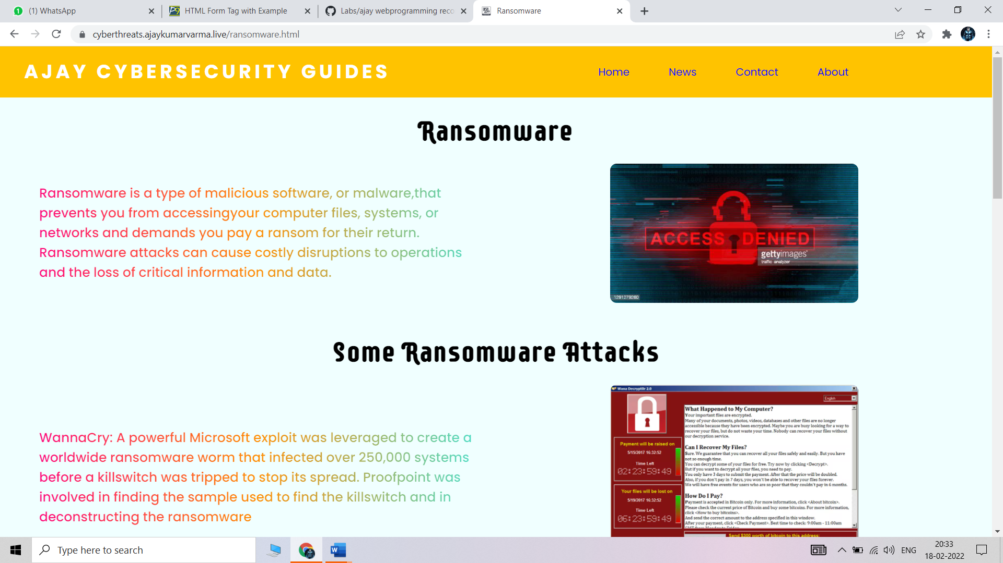

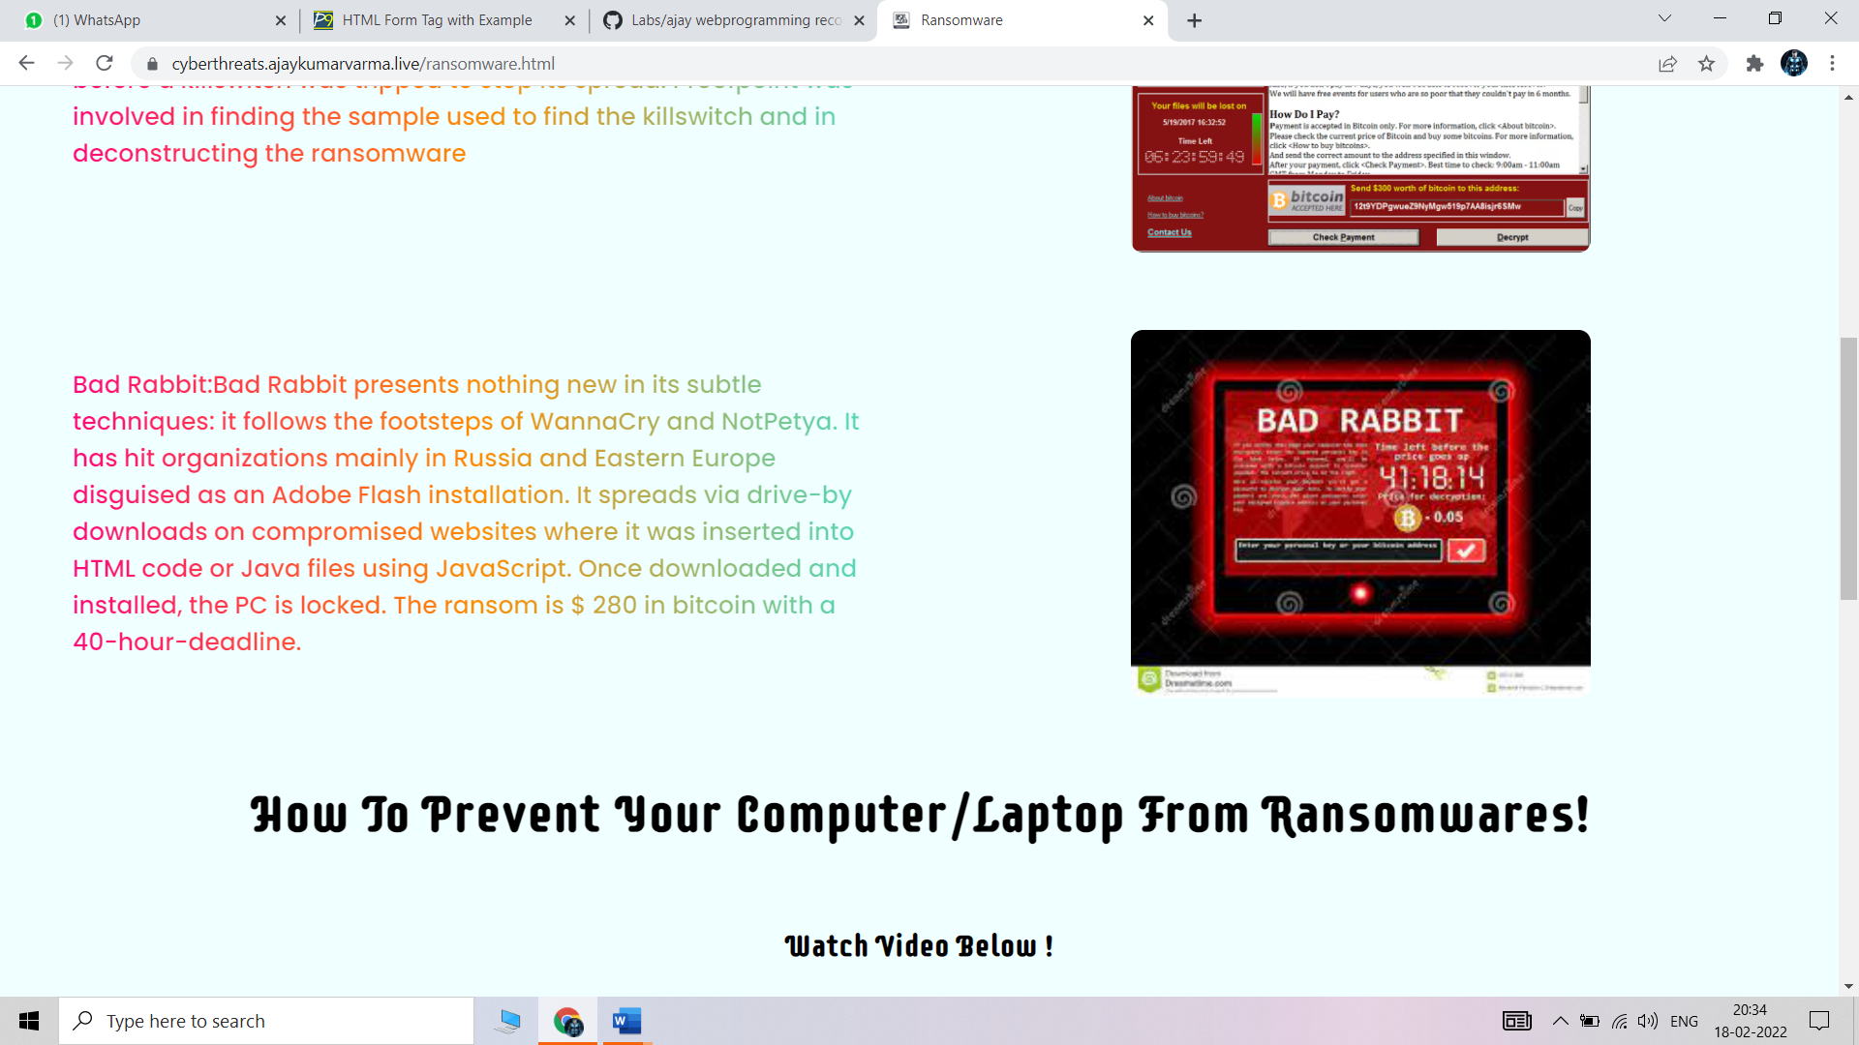

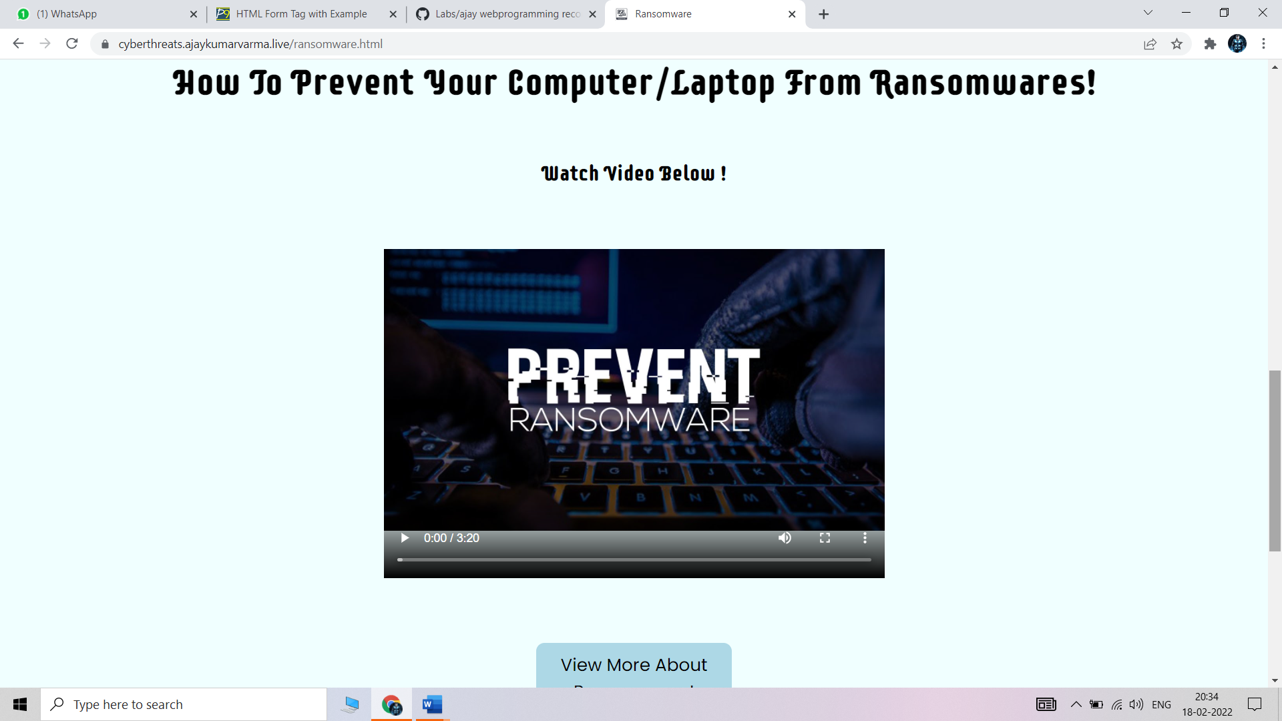

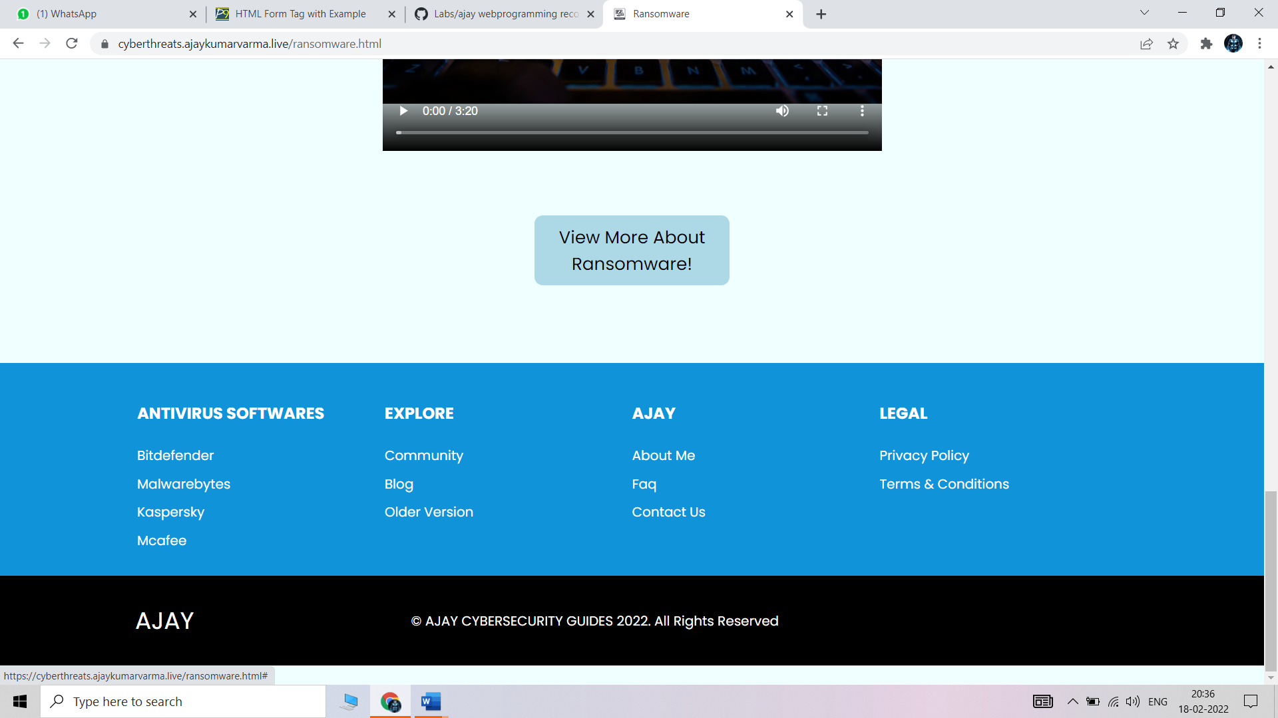

# **Week - 9**

# 1.What is Django, what is the framework that is used to implement Django.

## **DJANGO**

## Django is a high-level Python web framework that encourages rapid development and clean, pragmatic design. Built by experienced developers, it takes care of much of the hassle of web development, so you can focus on writing your app without needing to reinvent the wheel. It’s free and open source.

## Ridiculously fast.

## Django was designed to help developers take applications from concept to completion as quickly as possible.

## Reassuringly secure.

## Django takes security seriously and helps developers avoid many common security mistakes.

## Exceedingly scalable.

## Some of the busiest sites on the web leverage Django’s ability to quickly and flexibly scale.

## 

# **FRAMEWORK**

## Rich ecosystem

## Read Django like a system, developers say. What they mean is that there are many third-party applications that come with Django. These applications can be integrated depending on project requirements. To imagine this better, think of Legos. There are many different Lego blocks. In app development, an authorization “block” or email sending “block” is present in almost every project. Django consists of many applications — such as for authorization and sending emails — that can easily be plugged into a system.

## Maturity. Django has been around for 11 years and has gone through stages of significant improvement. A lot of things have been brought to perfection and many new things have been added. Most importantly, when you’re trying to figure out how something should work in Django, you can usually find the answer. Thousands of people must have already solved any issue you’re dealing with, and you can find a solution provided by the passionate Django community.

## Admin panel by default

## Admin panels are designed to help you manage your application. A Django admin panel is generated automatically from Python code, whereas creating an admin panel manually would take a lot of time and be absolutely pointless.

## There’s a lot of room for customization in the Django admin panel thanks to third-party applications. Additionally, Django allows you to modify the interface with third-party wrappers and add dashboards unique to your needs.

## Good for SEO

## Python is famous for having human-readable code, and that’s an advantage if you want your site to rank high in search results. With Django, you can generate readable website URLs and links using the most relevant keywords and search engine optimization (SEO) best practices.

## After all, a domain name is just a “human-readable” string that maps to a “computer friendly” set of numbers, known as an IP address. People fixate on getting the right domain name, but tend to neglect what the URL slug is—Django can fix that.

## Pluggable

## Django is pluggable by nature and can be extended with plugins. Plugins are software components that allow developers to add a specific feature to an app, leaving a lot of scope for customization. There are hundreds of packages to help you add Google Maps, create complex permissions, or connect to Stripe to process payments. And if you need to scale your project in the future, you can unplug some components and replace them with others that meet your current needs.

## Libraries

## Every programming language comes with its own set of libraries for solving common tasks. A software library includes prewritten code, classes, procedures, scripts, configuration data, and more. As a rule, a library is added to a program to provide more functionality or to automate a process without manually writing new code. This reduces time to market.

## Django allows developers to use libraries when building any project. Some popular libraries include the Django REST framework, which is responsible for building application programming interfaces (APIs); Django CMS, which is designed to manage website content; and Django-allauth, which is an integrated set of Django applications for authentication, registration, account management, and third-party (social) account authentication.

## ORM

## Django is valued for its object-relational mapper that helps developers interact with databases. An object-relational mapper (ORM) is a library that automatically transfers data stored in databases such as PostgreSQL and MySQL into objects commonly used in application code.

## **2.** **What are the prerequisites to implement Django.**

## There are many prerequisites to learn Django:

## The basic syntax of the Python

## Python functions

## importing external modules

## understanding of Python Path concepts

## conditional operators and loops

## string manipulation operations

## Regular Expression (RE)

## object-oriented concepts

## Learn REST APIs and JSON

## Database Management and SQL queries

## **3.** **How to install and run Django**

## Install Django[¶](https://docs.djangoproject.com/en/1.8/howto/windows/#install-django)

## Django can be installed easily using pip.

## In the command prompt, execute the following command: pip install django. This will download and install Django.

## After the installation has completed, you can verify your Django installation by executing django-admin --version in the command prompt.

## Use the Django admin console

## Create a superuser. You will be prompted to enter a username, email, and password. python manage. py createsuperuser

## Start a local web server: python manage. py runserver.

## Log in to the admin site using the username and password you used when you ran createsuperuser .

## 

## **4.** **Write a very basic program using Django.**

django_admin startproject hello_world_project

hello_world_project/

Manage.py

helloworld_project/

__init__.py

Settings.py

Urls.py

Asgi.py

migrating and testing project

cd hello_world_project

python manage.py migrate

python manage.py runserver

## 

## 

## **5.** **What is a database.Which database is by default in Django.**

## 

## 

## A database is an organized collection of structured information, or data, typically stored electronically in a computer system. A database is usually controlled by a [database management system (DBMS)](https://www.oracle.com/in/database/what-is-database/#WhatIsDBMS). Together, the data and the DBMS, along with the applications that are associated with them, are referred to as a database system, often shortened to just database.

## Data within the most common types of databases in operation today is typically modeled in rows and columns in a series of tables to make processing and data querying efficient. The data can then be easily accessed, managed, modified, updated, controlled, and organized. Most databases use structured query language (SQL) for writing and querying data.

## 

## By default, the configuration uses SQLite. If you’re new to databases, or you’re just interested in trying Django, this is the easiest choice. SQLite is included in Python, so you won’t need to install anything else to support your database.

## 

## **6. What is the framework and advantages of Django.**

## 

## 

## Rich ecosystem

## Read Django like a system, developers say. What they mean is that there are many third-party applications that come with Django. These applications can be integrated depending on project requirements. To imagine this better, think of Legos. There are many different Lego blocks. In app development, an authorization “block” or email sending “block” is present in almost every project. Django consists of many applications — such as for authorization and sending emails — that can easily be plugged into a system.

## Maturity. Django has been around for 11 years and has gone through stages of significant improvement. A lot of things have been brought to perfection and many new things have been added. Most importantly, when you’re trying to figure out how something should work in Django, you can usually find the answer. Thousands of people must have already solved any issue you’re dealing with, and you can find a solution provided by the passionate Django community.

## 

## Admin panel by default

## Admin panels are designed to help you manage your application. A Django admin panel is generated automatically from Python code, whereas creating an admin panel manually would take a lot of time and be absolutely pointless.

## There’s a lot of room for customization in the Django admin panel thanks to third-party applications. Additionally, Django allows you to modify the interface with third-party wrappers and add dashboards unique to your needs.

## Good for SEO

## 

## Python is famous for having human-readable code, and that’s an advantage if you want your site to rank high in search results. With Django, you can generate readable website URLs and links using the most relevant keywords and search engine optimization (SEO) best practices.

## After all, a domain name is just a “human-readable” string that maps to a “computer friendly” set of numbers, known as an IP address. People fixate on getting the right domain name, but tend to neglect what the URL slug is—Django can fix that.

## Pluggable

## Django is pluggable by nature and can be extended with plugins. Plugins are software components that allow developers to add a specific feature to an app, leaving a lot of scope for customization. There are hundreds of packages to help you add Google Maps, create complex permissions, or connect to Stripe to process payments. And if you need to scale your project in the future, you can unplug some components and replace them with others that meet your current needs.

## 

## 

## Libraries

## Every programming language comes with its own set of libraries for solving common tasks. A software library includes prewritten code, classes, procedures, scripts, configuration data, and more. As a rule, a library is added to a program to provide more functionality or to automate a process without manually writing new code. This reduces time to market.

## Django allows developers to use libraries when building any project. Some popular libraries include the Django REST framework, which is responsible for building application programming interfaces (APIs); Django CMS, which is designed to manage website content; and Django-allauth, which is an integrated set of Django applications for authentication, registration, account management, and third-party (social) account authentication.

## ORM

## Django is valued for its object-relational mapper that helps developers interact with databases. An object-relational mapper (ORM) is a library that automatically transfers data stored in databases such as PostgreSQL and MySQL into objects commonly used in application code.

## 

## **7. How to create an environment to start a new project in Django.**

## 

## 1. Install Package. First, install python3-venv package by using the following command.

## 2. Create a Directory. $ mkdir djangoenv. ...

## 3. Create Virtual Environment. $ python3 -m venv djangoenv. ...

## 4. Activate Virtual Environment.

## 

## **8.What is the difference between project and app.**

## 

## A *project* refers to the entire application and all its parts.

## An *app* refers to a submodule of the project. It's self-sufficient and not intertwined with the other apps in the project such that, in theory, you could pick it up and plop it down into another project without any modification. An *app* typically has its own *models.py* (which might actually be empty). You might think of it as a standalone python module. A simple project might only have one app.

## For your example, the *project* is the whole website. You might structure it so there is an *app* for articles, an *app* for ranking tables, and an *app* for fixtures and results. If they need to interact with each other, they do it through well-documented public classes and accessor methods.

## The main thing to keep in mind is this level of interdependence between the *apps*. In practice it's all one *project*, so there's no sense in going overboard, but keep in mind how co-dependent two apps are. If you find one app is solving two problems, split them into two apps. If you find two apps are so intertwined you could never reuse one without the other, combine them into a single app.

# **Week - 10**

## AIM- How to implement a form in django

# Step : 1 install django in command prompt

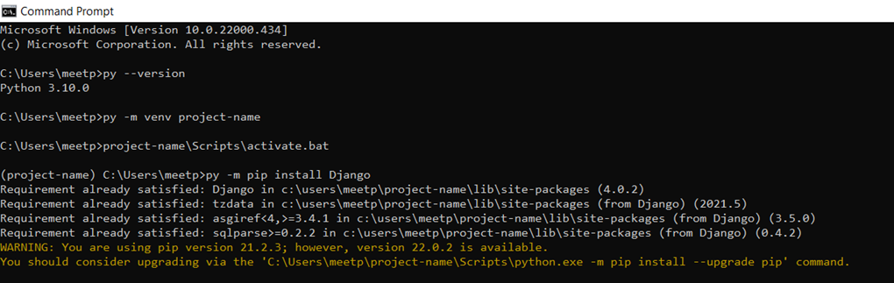

## Step : 2 create an environment

Step : 3 open visual studio , folder five (as per me ) in visual studio ,files will be uploaded

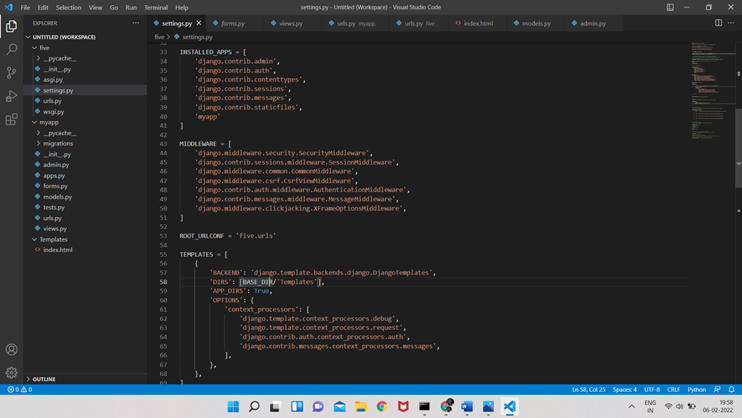

Step : 4 For execution of the form go to command prompt

type: python manage.py makemigrations

thereafter type: python manage.py migrate

after type:python manage.py runserver

we will get an ip address

copy that and paste it in chrome

add : /form to the address

<http://127.0.0.1:8000/form>

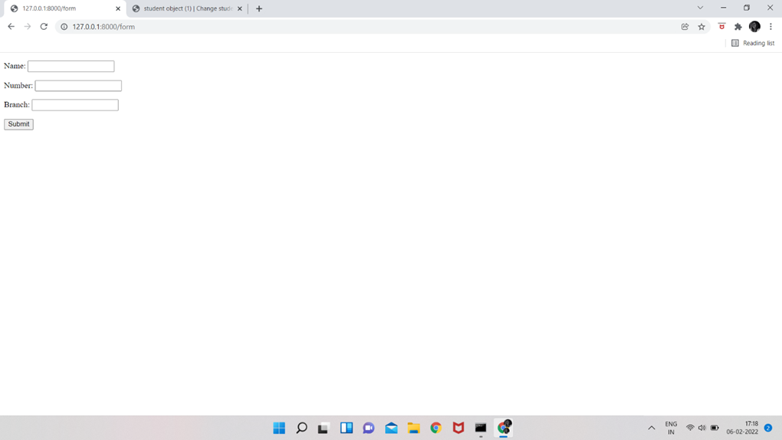

Step : 5 We will get a form like this

thereafter create a user id for dijango

by typing in cmd propmt : python manage.py createsuperuser

Step : 6 http://127.0.0.1:8000/admin with/admin

again go to chrome and paste the address

will get a site consist of username and passowed

will get an Django administration site

login

in student option we can cretae as many as student objects and we can delete too

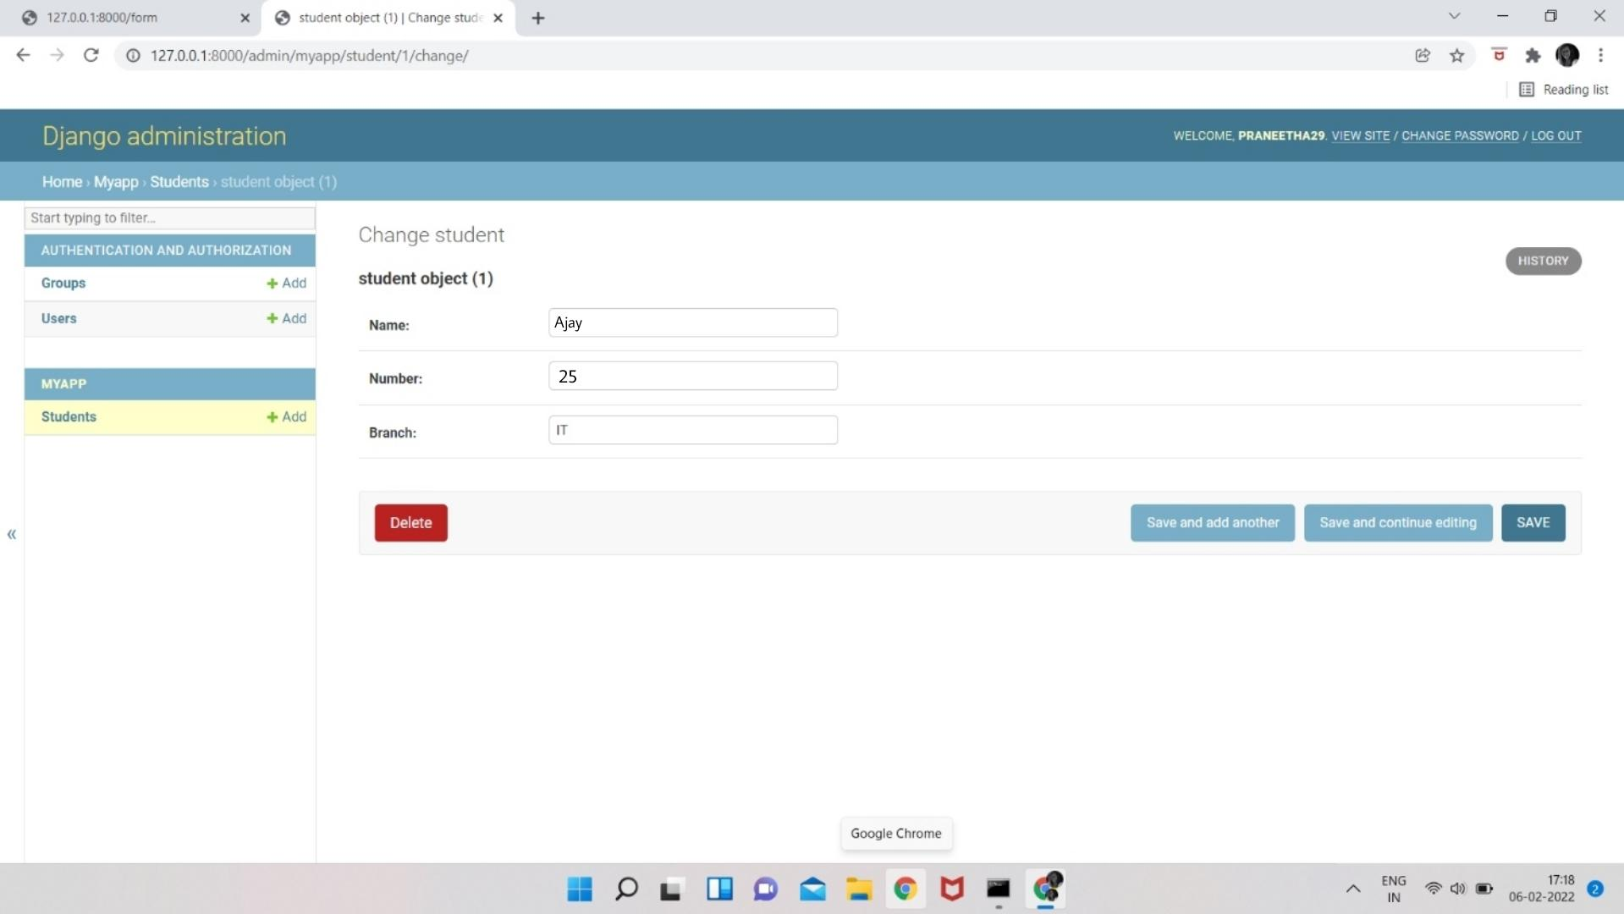

# **Week - 11**

## 1.CRUD operations on the form.

## CRUD Meaning: CRUDis an acronym that comes from the world of computer programming and refers to the four functions that are considered necessary to implement a persistent storage application: **create, read, update** and **delete**.

## 

|  |  |  |
| --- | --- | --- |
| **Letter** | **Operation** | **Function** |
| C | Create | Insert |
| R | Create | Select |
| U | Update | Edit |
| D | Delete | Delete |

CREATE:

## UPDATE

Step 1: Select and open one of the objects created.(say student object (1))

## 

Step 2: Select the Save and continue editing button to update the object

## DELETE

Step 1: Select the student object to delete.

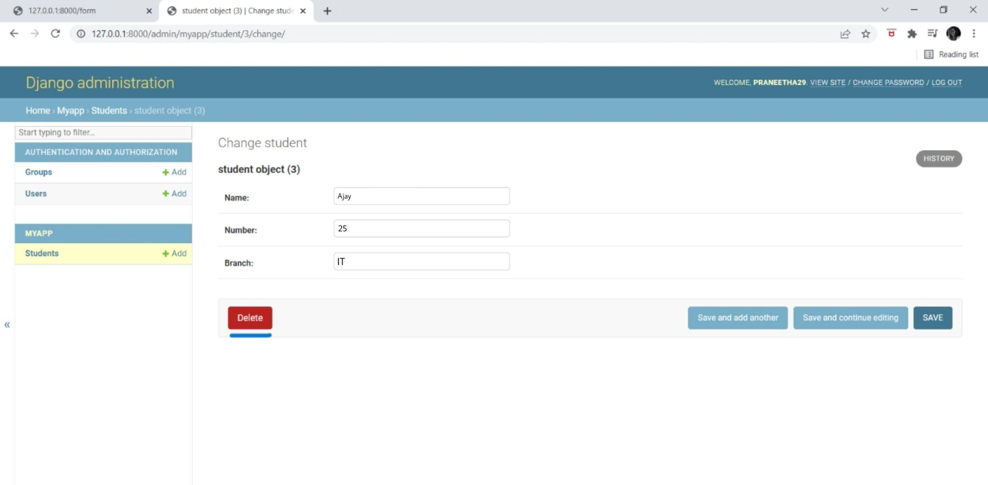

Step 2: The student “student object(3)” was deleted successfully.

